**Google Cloud Console set up steps:**

Sign into Google cloud console with a valid gmail id.

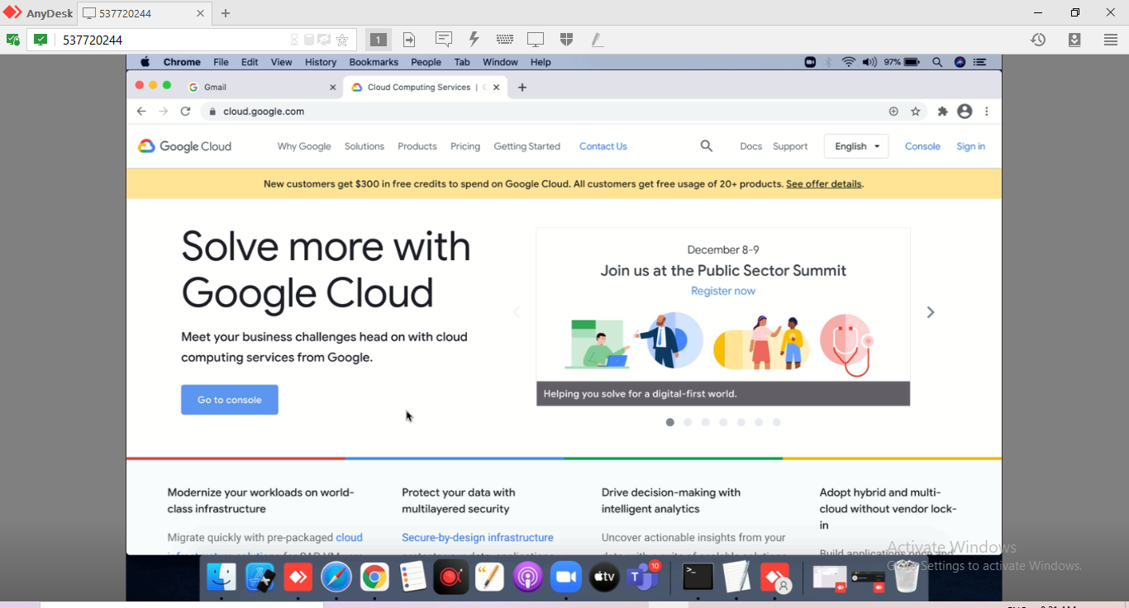

Click on go to Console

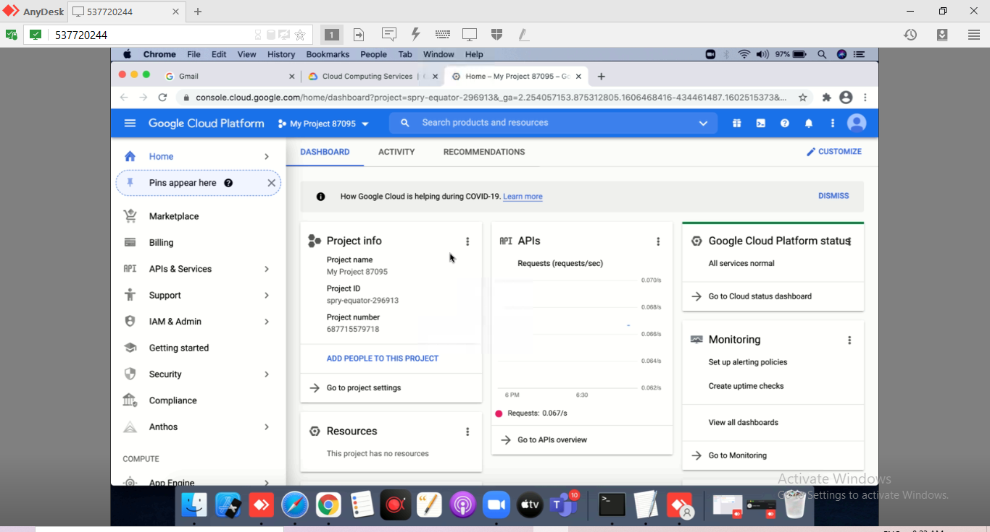

IN the menu options on left side under compute select on Kubernetese Engine ---> Cluster

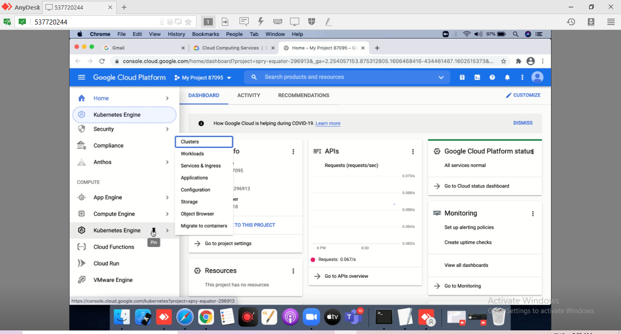

Click on Cluster --> click on sign up for free trial

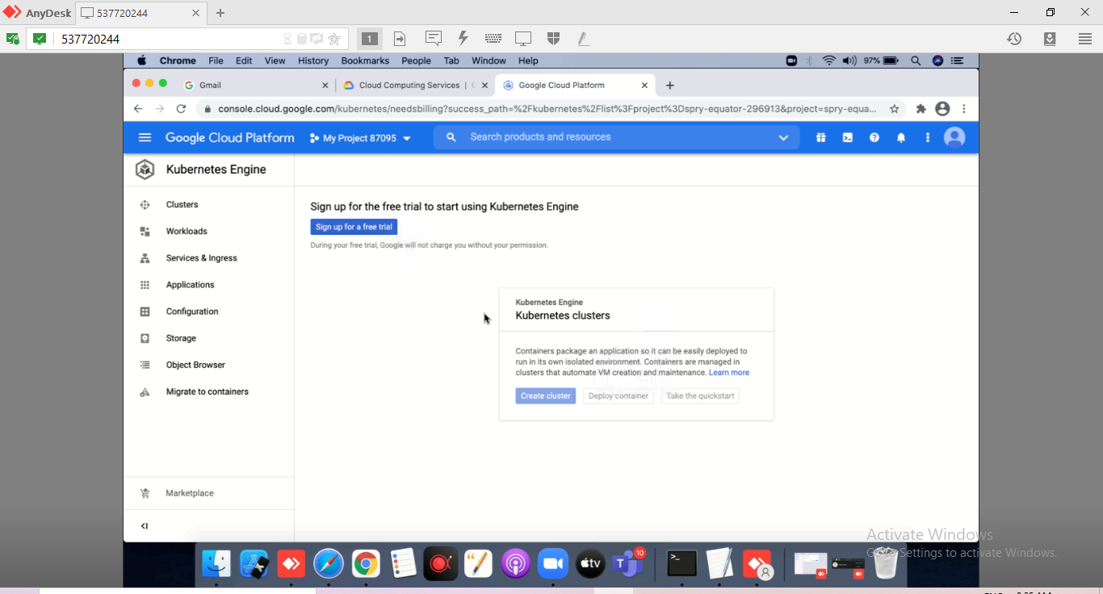

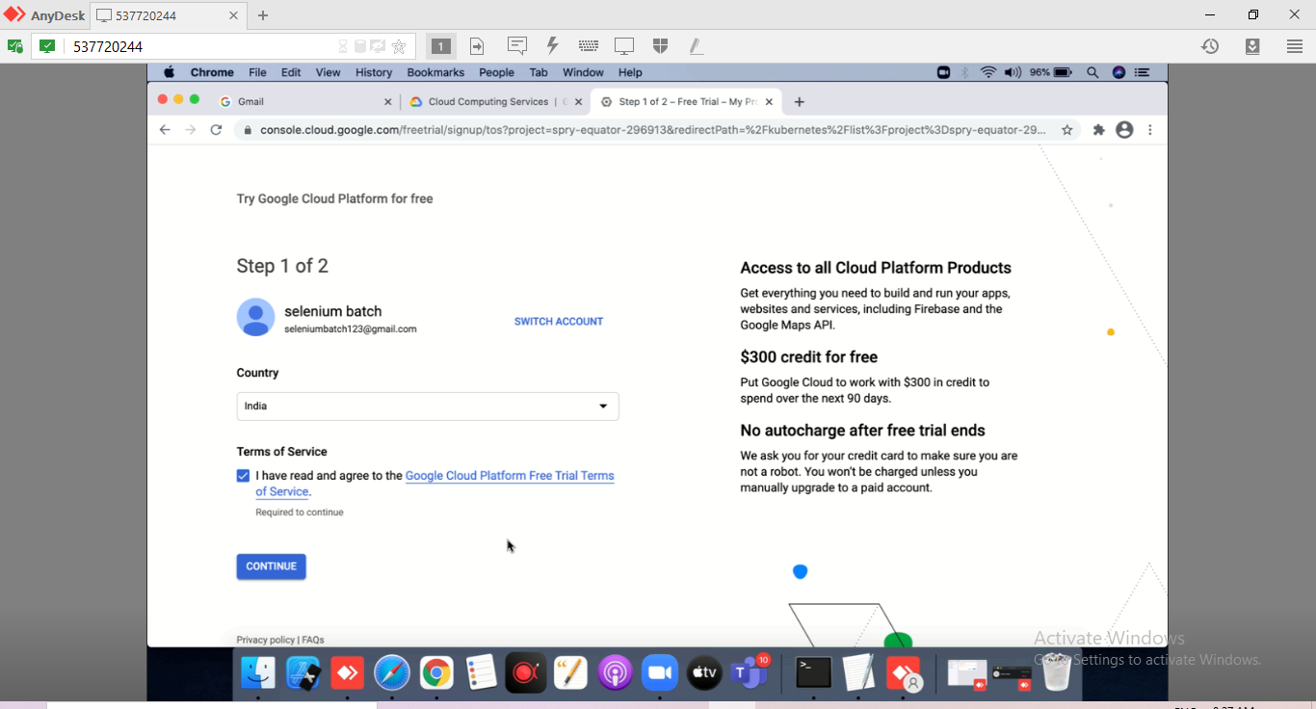

Select country and accept the terms.

Click on Continue

Provide information as shown below

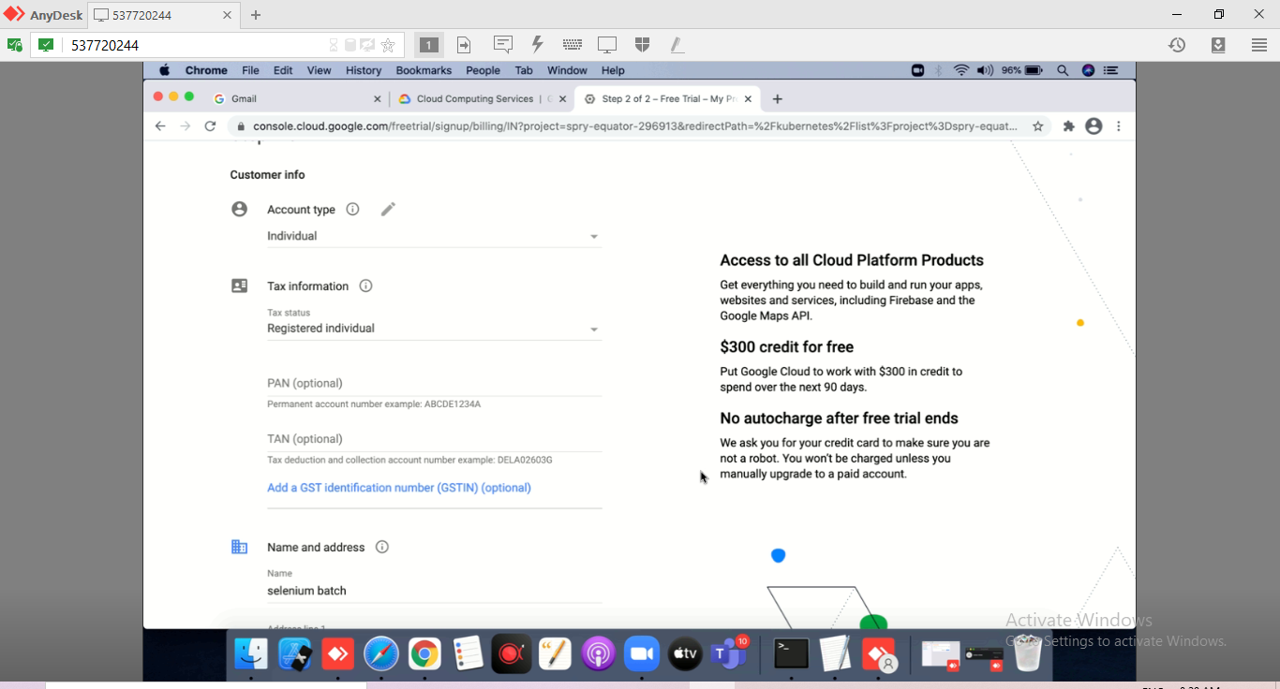

Scroll further down and provide your address and card details

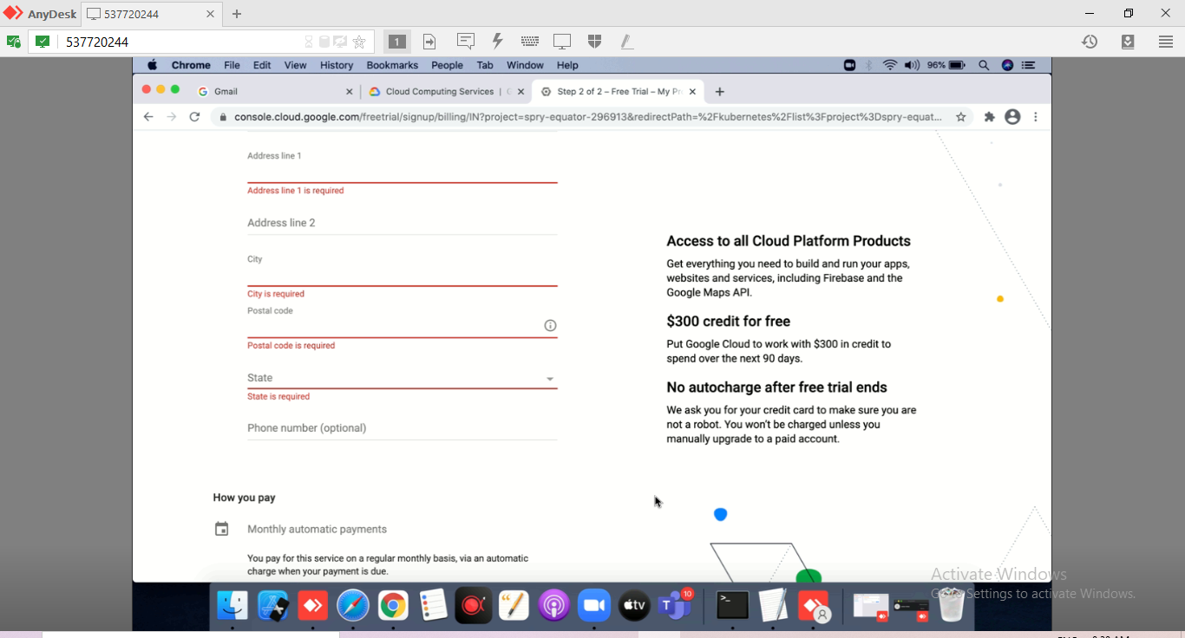

Provide card details under payment method, Use valid credit card only.

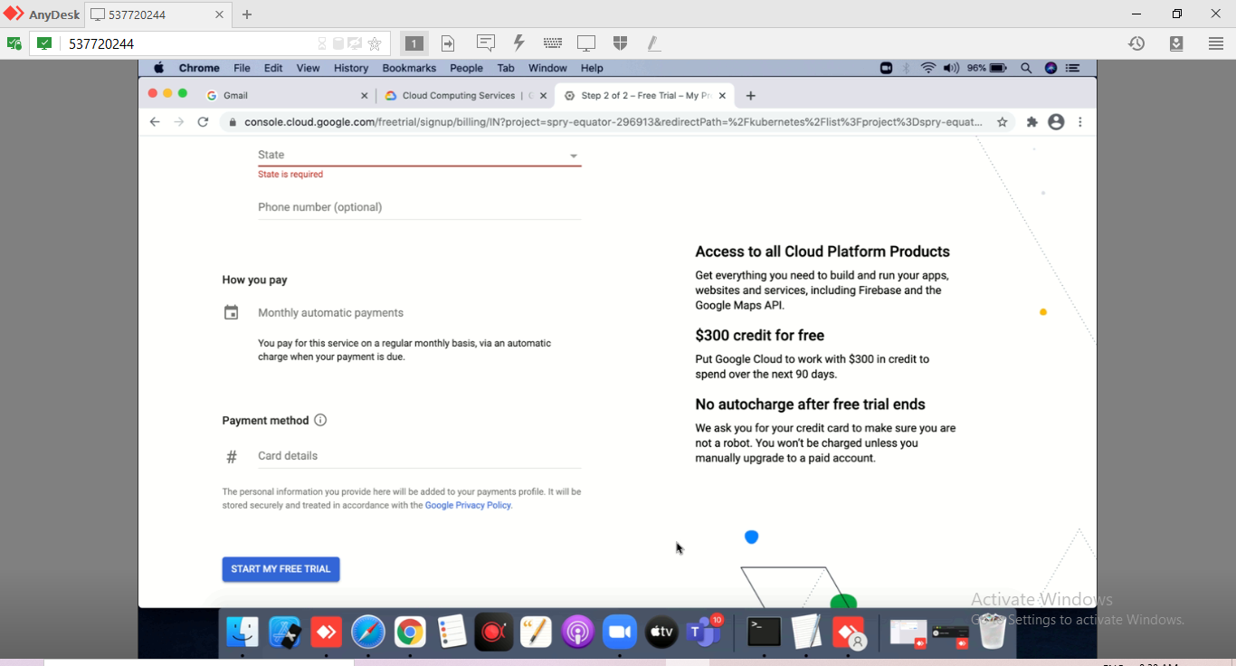

Click on Start my free trial. Your set up is complete for google cloud platform.

We are now ready for creation of kubernetese cluster.

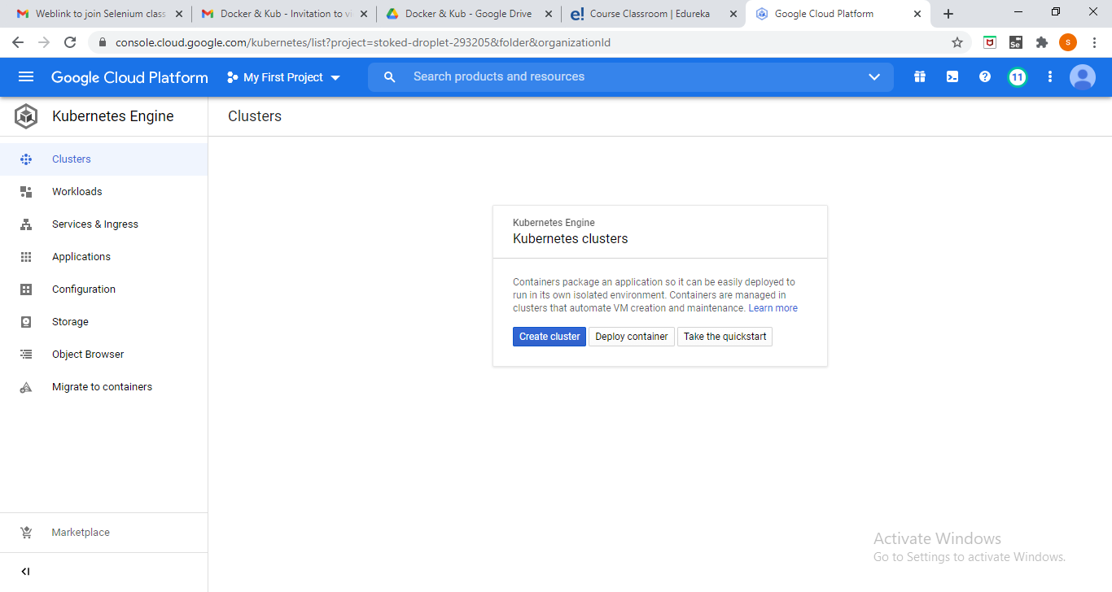

Thanks

Sonal Mittal